|  |
| --- |
| MCGRAW HILL FINANCIAL |
| User Manual |
| Job Support for Lower Environment |
|  |
| **Shubham Joshi** |
| **4/21/2016** |

Table of Contents

1. Accessing Report……………………………………………………………………………………………………………………………...2

2. Viewing Report—Flow Chart…………………………………………………………………………………………………………....3

3. Key Functionalities –Flow Chart…………………………………………………………………………………………………..…..4

4. Parameter Details 5

Environment 5

Server 5

Job Status 5

Job Name 5

5. Information Available 5

6. Additional Details 6

1. Link to Report

<http://sunfire/Reports/Pages/Report.aspx?ItemPath=%2fJob+Monitoring%2fJobSupport> **Internet explorer is recommended. Use CiqDev credentials.**

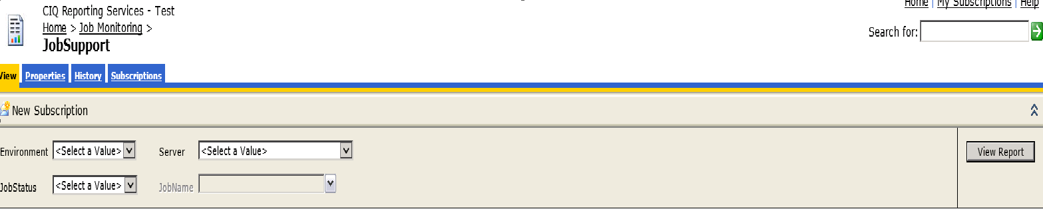

Access and Generate Report

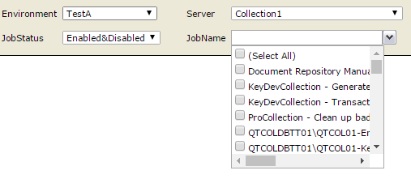

Open URL

Use CiqDev   
credentials

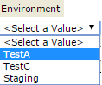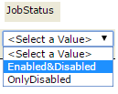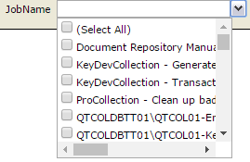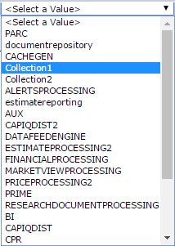

Click to View

Report

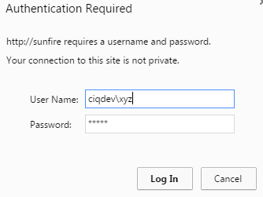

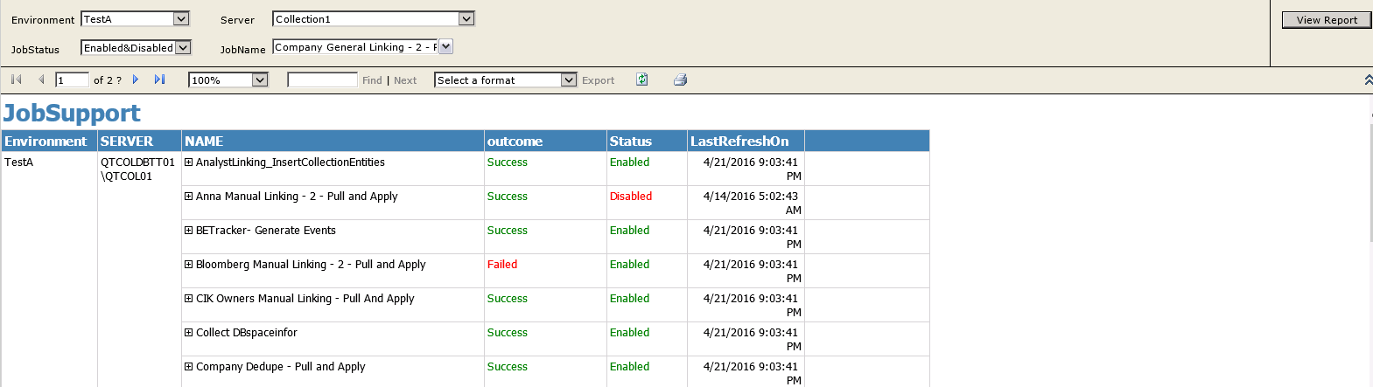

Functionalities



Got Next \Last Page

Search

Export

Print

Refresh

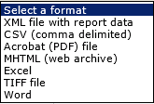

Use Expand(+)  
To View Error & more details



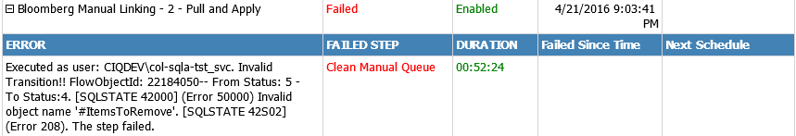

# Parameter Details

## Environment

* Corresponds to Active Test, Inactive test, Staging.
* When Test A is active Test DB will point to NJQTPRMDBTST01.
* When Test B is active Test DB will point to NJQTPRMDBTST02.
* Staging DB will point to MUSTANG.

## Server

Corresponds to a role name.  
Prime is NJQTPRMDBTST01 when Test A is active and NJQTPRMDBTST02 when Test B is active.  
Use this T-SQL to get instance name corresponding to a role.  
select data_source from sys.servers where name like ‘RollName’

Ex: To know instance name for ‘collection1’ role in Test A.

1. Connect to any Test A server (as we know NJQTPRMDBTST01 belongs to Test A)
2. Use select data_source from sys.servers where name like ‘%collection1%

## Job Status

**Enabled & Disabled**  
Display all the jobs in a given Environment , role.  
 **Disabled**  
Displays only disabled jobs.

## Job Name

Displays all the jobs for a given Environment , Role .  
Can select between single or multiple jobs.

# Information Available from Report:

These are the first set of information that is available when report is viewed

* **Environment** : Selected Environment
* **Server**: Server Name corresponding to selected role.
* **Outcome:** Shows success or failure for the last run.

Success is marked **Green** and failure is marked **Red**.

* **Status**: Can either be enabled or disabled.

Similar to Outcome enabled jobs are shown with **Green** color and disabled are marked **Red**.

* **Last Refreshed On :** This shows when was the last time report gets refreshed. Generally it gets refreshed every 1 hour may take more as well.

# Additional Details Gives additional details like

* **Error Message:** Gives complete error message for failed jobs
* **Failed Step :** Name of the failed step
* **Duration :** Time taken in HH:MM:SS
* **Failed Since Time:** Time when it last failed
* **Next Schedule :** Job’s next schedule

